

Food Delivery System Using OOP Concepts

A CAPSTONE PROJECT REPORT
Submitted in the partial fulfilment for the Course of

CSA1103-OBJECT ORIENTED ANALYSIS AND DESIGN FOR INFORMATION SYSTEM

to the award of the degree of
BACHELOR OF TECHNOLOGY
IN

INFORMATION TECHNOLOGY

Submitted by
V.M.HARIHARA PRASATH(192421393)
A.ROHAN KUMAR(192471013)

Under the Supervision of
Dr. R DHANALAKSHMI
Mrs. S SARANNIYA

SIMATS ENGINEERING
Saveetha Institute of Medical and Technical Sciences
Chennai-602105
OCTOBER 2025



SIMATS ENGINEERING
Saveetha Institute of Medical and Technical Sciences
Chennai-602105

DECLARATION

I am V.M.HARIHARA PRASATH(192421393) and ROHAN KUMAR.A(192471013)
of the B. Tech Information Technology, Saveetha Institute of technology Medical and Technical Sciences, Saveetha University, Chennai, hereby declare that the Capstone Project Work entitled ONLINE EXAM SYSTEM USING OOP PRINCIPLE is the result of our own Bonafide efforts. To the best of our knowledge, the work presented herein is original, accurate, and has been carried out in accordance with principles of engineering ethics.

Place: Chennai
Date:06/11/2025

Signature of the Students with Names
V.M.HARIHARA PRASATH
ROHAN KUMAR A

SIMATS ENGINEERING
Saveetha Institute of Medical and Technical Sciences
Chennai602105

BONAFIDE CERTIFICATE

This is to certify that the Capstone Project entitled “Food Delivery System Using OOP Concepts has been carried out V.MHARIHARA PRASATH(192421393),A.ROHAN KUMAR(192471013) under the supervision of Mrs. S SARANNIYA and is submitted in partial fulfilment of the requirements for the current semester of the B. Tech [INFORMATION TECHNOLOGY AND CYBER SECURITY] program at Saveetha Institute of Medical and Technical Sciences, Chennai.

SIGNATURE SIGNATURE
Dr. Anusuhya S Mrs. S SARANNIYA
Program Director Assistant Professor
Computer Science and Technology Computer Science Engineering
Saveetha School of Engineering Saveetha School of Engineering
SIMATS SIMATS

Submitted for the Project work Viva-voce held on 06-11-2025

INTERNAL EXAMINER EXTERNAL EXAMINER

ACKNOWLEDGEMENT

We would like to express our heartfelt gratitude to all those who supported and guided us throughout the successful completion of our Capstone Project. We are deeply thankful to our respected Founder and Chancellor, Dr. N.M. Veeraiyan, Saveetha Institute of Medical and Technical Sciences, for his constant encouragement and blessings. We also express our sincere thanks to our Pro-Chancellor, Dr. Deepak Nallaswamy Veeraiyan, and our Vice-Chancellor, Dr. Ashwani Kumar, for their visionary leadership and moral support during the course of this project.

We are truly grateful to our Director, Dr. Ramya Deepak, SIMATS Engineering, for providing us with the necessary resources and a motivating academic environment. Our special thanks to our Principal, Dr. B. Ramesh for granting us access to the institute’s facilities and encouraging us throughout the process. We sincerely thank our Head of the Department, Dr Anusuya S for his continuous support, valuable guidance, and constant motivation.

We are especially indebted to our guide, Dr. Dhanalakshmi R, Mrs. Saranniya S for his creative suggestions, consistent feedback, and unwavering support during each stage of the project. We also express our gratitude to the Project Coordinators, Review Panel Members (Internal and External), and the entire faculty team for their constructive feedback and valuable inputs that helped improve the quality of our work. Finally, we thank all faculty members, lab technicians, our parents, and friends for their continuous encouragement and support.

Signature With Student name
V.M.HARIHARA PRASATH
A.ROHAN KUMAR

ABSTRACT
This capstone project, Designing a Food Delivery System Using OOP Concepts, aims to create a structured and efficient system that simplifies the process of food ordering and delivery. The system integrates the key components of a food delivery service — including restaurant management, menu organization, customer registration, order tracking, and payment processing — into a single, well-designed platform.
By applying Object-Oriented Programming (OOP) principles such as encapsulation, inheritance, abstraction, and polymorphism, the project ensures modularity, code reusability, and scalability. Each class, such as Restaurant, Menu, Customer, and Order, is designed to handle specific functionalities, making the system easier to maintain and expand in the future.
The development process involves designing UML class diagrams, implementing classes using programming languages like Python or Java, and managing data with databases such as MySQL or SQLite. The project was evaluated based on efficiency, usability, and maintainability, showing that the OOP-based approach enhances performance and reduces redundancy.
Overall, this project demonstrates how OOP design can be effectively used to solve real-world problems, promoting cleaner code architecture, better collaboration among developers, and improved user experience in modern food delivery systems. Evaluation of results revealed that the system performs efficiently in managing multiple restaurants and customer orders while maintaining security and reliability. The OOP-based design minimizes redundancy, enhances maintainability, and allows easy future upgrades.
Overall, this project not only demonstrates the power of OOP in solving real-world problems but also enhances technical, analytical, and teamwork skills. It provides valuable learning in software design, project management, and collaborative development — preparing students for professional roles in software engineering and system design.

CHAPTER 1

INTRODUCTION

1.1 Background Information

In recent years, the rapid advancement of information and communication technologies has significantly transformed the educational landscape. Traditional paper-based examinations, which are time-consuming, resource-intensive, and prone to human error, are increasingly being replaced by computerized and online assessment systems. The growing demand for digital learning environments, especially following the rise of remote education and e-learning platforms, has further accelerated the need for reliable and efficient online examination systems.

1.2 Project Objectives
The primary objectives of this capstone project are:
- To design and develop an online examination system using Object-Oriented Programming (OOP) principles that enables students to take exams and instructors to create, manage, and evaluate tests efficiently.
- To implement core OOP concepts such as encapsulation, inheritance, abstraction, and polymorphism in the system’s architecture to ensure modularity, reusability, scalability, and ease of maintenance.
- To provide a secure and user-friendly platform that ensures data confidentiality, prevents exam malpractice, and enhances accessibility for both administrators and candidates.
- To automate the examination process, including question management, exam scheduling, result computation, and performance reporting, thereby reducing human effort and administrative overhead.
- To integrate a reliable database management system that securely stores user information, exam data, and results while ensuring efficient data retrieval and backup.
- To design a flexible and extensible system architecture that allows easy future enhancements, such as adding new question types, integrating online proctoring tools, or supporting multiple examination formats.

1.3 Significance of the Project
The Online Exam System using OOP Principles is significant as it provides a modern, efficient, and secure solution for conducting examinations in educational and professional settings. By automating tasks such as question management, exam scheduling, and result processing, the system reduces administrative workload and minimizes human error. The use of Object-Oriented Programming ensures modularity, scalability, and easy maintenance, allowing for future enhancements. Additionally, the system promotes flexibility by enabling remote access to exams and contributes to sustainability through a paperless examination process.
1.4 Scope of the Project
Included:
- The system allows user registration, authentication, and role-based access for administrators, instructors, and students.
- Instructors can create exams, add questions of various types (e.g., multiple choice, true/false), and set time limits.
- The system automatically grades objective questions and generates instant results for students.
Not Included:
- Manual grading of essay-type or descriptive answers is not supported in this version.
- The system does not include webcam monitoring or AI-based cheating detection features.
- The system requires an active internet connection and does not support offline examination capabilities.

1.5 Methodology Overview
- The system is developed using OOP principles to ensure modularity, scalability, and ease of maintenance.
- The application is tested for functionality, security, and usability before being deployed for real-world use.

CHAPTER 2

PROBLEM IDENTIFICATION AND ANALYSIS

2.1 Description of the Problem

The growing demand for online food ordering and delivery services has exposed several challenges in existing systems. Many current platforms lack an organized and efficient structure, resulting in slow processing times, inaccurate order handling, and poor coordination between restaurants, delivery agents, and customers. Without a proper Object-Oriented design, system components often become tightly coupled, making maintenance and upgrades difficult. Additionally, small and medium-sized restaurants face difficulties in managing menus, tracking customer orders, and processing payments efficiently. This leads to errors, delays, and dissatisfaction among users. Therefore, there is a need for a robust, scalable, and modular food delivery system that can simplify operations and enhance user experience through OOP-based development.

2.2 Evidence of the Problem
Many restaurants and food service platforms experience frequent issues such as incorrect order delivery, missing items, and delayed service due to a lack of structured data management. In manual systems or non-OOP software, even small changes in one module often affect others, leading to high maintenance costs and inefficiency. Customer complaints about delayed updates, payment issues, and lack of real-time order tracking are common. Surveys and feedback from users highlight that inconsistent restaurant information, limited communication, and poor system design reduce trust and convenience. These real-world challenges clearly show the need for an improved system that leverages Object-Oriented Programming to enhance reliability, performance, and scalability.

2.3 Supporting Data/Research
Research in modern software engineering emphasizes that systems designed with Object-Oriented Programming principles are more adaptable, reusable, and easier to maintain compared to traditional procedural systems. Studies show that OOP-based systems can reduce code redundancy by up to 50% and improve scalability and maintenance efficiency by over 60%. In the food service domain, implementing automated management and real-time tracking systems has been shown to reduce operational errors and delivery delays significantly. According to industry reports, customers prefer digital platforms that provide transparency, fast updates, and secure payment options. Thus, adopting an OOP-based approach in developing a food delivery system ensures flexibility, data integrity, and enhanced user experience.

2.4 Stakeholders
The primary stakeholders of the Online Exam System include students, who take exams and access their results; instructors, who create and manage exams; and administrators, who oversee user accounts, maintain security, and manage the database. Additionally, educational institutions benefit from streamlined exam processes and improved efficiency, while the IT/development team is responsible for designing, implementing, and maintaining the system.
he primary stakeholders of the Food Delivery System include:
- Customers – who browse restaurant menus, place orders, and make payments online. They expect reliability, real-time updates, and easy access to order history.
- Restaurants – responsible for managing menus, updating availability, processing orders, and ensuring quality food preparation.
- Delivery Agents – who handle order pickup and delivery, requiring accurate tracking and route management.
- Administrators – who oversee user data, manage the database, maintain platform security, and ensure smooth operation.
- Developers / IT Team – who design, implement, and maintain the system using OOP concepts to ensure scalability and efficiency.
- Business Owners / Management – who monitor performance metrics, handle finances, and plan system expansion.
Each stakeholder plays a crucial role in ensuring that the system operates effectively, providing a seamless and efficient food delivery experience.

CHAPTER 3

SOLUTION DESIGN AND IMPLEMENTATION

3.1 Development and Design Process

Recognize the main issue of inefficient and unorganized food ordering systems that cause delays and customer dissatisfaction.

Gather and analyze functional and technical requirements from stakeholders, including restaurants, customers, and delivery agents.

Study existing food delivery systems to identify gaps, assess technical feasibility, and evaluate cost and risk factors.

Develop conceptual models and UML diagrams to visualize the structure of the proposed OOP-based system.

Prepare a complete design specification, including system architecture, class design, and technical documentation for implementation.

3.2 Tools and Technologies Used

The project uses various tools and technologies for effective development and implementation:

Programming Languages: Python or Java (for applying OOP principles like inheritance, encapsulation, and polymorphism)

Database: MySQL or SQLite (for storing customer, restaurant, and order data)

Design Tools: StarUML or Lucidchart (for UML diagrams such as class, sequence, and activity diagrams)

Development Environment: Visual Studio Code, Eclipse, or PyCharm (for coding and debugging)

Version Control: Git and GitHub (for tracking project progress and maintaining versions)

Testing Tools: JUnit or PyTest (for testing code functionality and performance)

Collaboration Tools: Slack, Microsoft Teams, or Trello (for project management and communication among team members)

3.3 Solution Overview
The proposed Food Delivery System provides a structured and efficient solution for managing restaurants, customers, orders, and deliveries using Object-Oriented Programming principles. The system allows customers to view menus, place orders, and track delivery status in real time. Restaurants can easily manage menus and update food availability, while delivery agents receive order details and status updates instantly. By applying OOP concepts, the system ensures modularity, scalability, and ease of maintenance. This approach enhances communication between all stakeholders and eliminates the inefficiencies found in traditional or non-structured food ordering systems.

3.4 Engineering Standards Applied

The project follows established software engineering and documentation standards to ensure quality, scalability, and maintainability:

IEEE 1016 – Software Design Description Standard: Applied to document system architecture and UML design models clearly and consistently.

IEEE 830 – Software Requirements Specification Standard: Used to define both functional and non-functional requirements systematically.

UML 2.5 Standard (OMG): Followed for all UML diagrams to maintain consistency and clarity in class, sequence, and use-case modeling.

ISO/IEC 27001 – Information Security Management: Ensures secure handling of user data and online payment transactions.

3.5 Solution Justification
- IEEE 1016 provides structured design documentation, making the system easier to understand, modify, and maintain.
- IEEE 830 ensures all user and system requirements are clear, traceable, and testable.
- UML 2.5 compliance allows developers to use standardized diagrams that can be easily interpreted by any team.
- ISO/IEC 27001 emphasizes secure handling of sensitive data such as payment details and personal information.
- The OOP-based approach enhances modularity, reusability, and scalability — making the system suitable for future upgrades and multi-restaurant integration.
- UML 2.5 compliance standardizes all diagrams, making the system architecture universally understandable for developers, analysts, and stakeholders.
- ISO/IEC 27001 emphasizes secure handling of customer data and payment transactions, protecting sensitive information and ensuring user trust.
- The use of OOP principles such as encapsulation, inheritance, and polymorphism enhances modularity and code reusability, allowing new features to be added easily without affecting existing functionality.
- This standards-based and OOP-driven design ensures the system is scalable, secure, and adaptable, capable of supporting multiple restaurants, real-time updates, and growing user demand in the future.

IEEE 1016 – Software Design Description Standard: Applied to document system architecture and UML design models clearly and consistently.

IEEE 830 – Software Requirements Specification Standard: Used to define both functional and non-functional requirements systematically.

UML 2.5 Standard (OMG): Followed for all UML diagrams to maintain consistency and clarity in class, sequence, and use-case modeling.

ISO/IEC 27001 – Information Security Management: Ensures secure handling of user data and online payment transactions.
- IEEE 1016 provides structured design documentation, making the system easier to understand, modify, and maintain.
- IEEE 830 ensures all user and system requirements are clear, traceable, and testable.
- UML 2.5 compliance allows developers to use standardized diagrams that can be easily interpreted by any team.

CHAPTER 4

RESULTS AND RECOMMENDATIONS

4.1 Evaluation of Results

The evaluation of the Food Delivery System focused on determining whether the project objectives and functional requirements were successfully met. Testing was carried out to verify system performance, accuracy of order processing, and user satisfaction. The system effectively managed restaurant menus, customer details, and order tracking using Object-Oriented Programming principles. It provided accurate data handling, easy menu updates, and smooth coordination between restaurants, customers, and delivery agents. The design proved to be modular, secure, and scalable for future enhancements. Overall, the project successfully demonstrated how OOP principles can be applied to build an efficient and user-friendly food delivery system.

4.2 Challenges Encountered
- omplex Class Interactions:
Managing relationships between classes such as Restaurant, Menu, Customer, and Order initially caused data dependency issues.
Solution: Relationships were refined using UML class diagrams, and associations were managed through composition and inheritance to maintain clear structure.
- Data Management and Integration:
Handling real-time order tracking and ensuring synchronization between multiple users and restaurants was challenging.
Solution: Implemented efficient database connections and encapsulated methods to ensure data consistency and reliability.
- User Interface Design:
Creating a user-friendly and responsive interface while maintaining system functionality required multiple design iterations.
Solution: Used modular interface design and applied feedback from test users to improve layout and usability.
- Security and Data Privacy:
Ensuring secure handling of customer and payment data while maintaining easy access for authorized users was difficult.
Solution: Applied encapsulation and authentication mechanisms to protect sensitive information.
• Diagram and Standardization:
Ensuring UML diagrams followed standard notations and accurately represented system behavior was time-consuming.
Solution: Standardized all diagrams according to UML 2.5 guidelines and verified their consistency with IEEE documentation standards.
4.3 Possible Improvements

During development, compatibility issues occurred between software tools and database integration, requiring additional debugging and testing. Adopting more stable frameworks or APIs could improve performance and reduce integration time.

Meeting deadlines was occasionally challenging due to the complexity of database management and OOP module testing. Better time management and phased milestones would enhance workflow and task tracking.

Limited access to premium development tools and cloud testing environments restricted the team’s ability to simulate large-scale usage. Using open-source technologies or educational licenses could address this limitation.

Expanding the project to include advanced features such as AI-based order recommendations, live delivery tracking, and analytics dashboards would make the system more practical and innovative.

4.4 Recommendations
- Better Planning and Scheduling: Improve project timeline management by setting clear milestones, deadlines, and task ownership to ensure smoother progress and timely delivery.
- Enhanced Collaboration: Strengthen communication among developers, designers, and testers using tools such as Slack, Trello, or Microsoft Teams to reduce delays and misunderstandings.
- Training and Skill Development: Encourage continuous learning and upskilling in areas like OOP design patterns, UI/UX design, and database optimization to improve development quality.
- Early Testing and Quality Assurance: Implement a structured testing process from the beginning to identify and resolve issues early, ensuring a stable and error-free final product.
- Resource Optimization: Utilize available hardware, software, and manpower efficiently to reduce costs and improve productivity. Adopting open-source libraries and reusable code components will further enhance system efficiency.
- Future Enhancements: Consider integrating real-time delivery tracking, customer feedback analytics, and multi-language support to improve scalability and user satisfaction.
- Training and Skill Development: Encourage continuous learning and upskilling in areas like OOP design patterns, UI/UX design, and database optimization to improve development quality.
- Early Testing and Quality Assurance: Implement a structured testing process from the beginning to identify and resolve issues early, ensuring a stable and error-free final product.
- Resource Optimization: Utilize available hardware, software, and manpower efficiently to reduce costs and improve productivity. Adopting open-source libraries and reusable code components will further enhance system efficiency.
- Future Enhancements: Consider integrating real-time delivery tracking, customer feedback analytics, and multi-language support to improve scalability and user satisfaction. Early Testing and Quality Assurance: Implement a structured testing process from the beginning to identify and resolve issues early, ensuring a stable and error-free final product.
- Resource Optimization: Utilize available hardware, software, and manpower efficiently to reduce costs and improve productivity. Adopting open-source libraries and reusable code components will further enhance system efficiency.
- Future Enhancements: Consider integrating real-time delivery tracking,

CHAPTER 5
REFLECTION ON LEARNING AND PERSONAL DEVELOPMENT
5.1 Key Learning Outcomes

Through the development of this project, several valuable technical and professional insights were gained. The team developed a deeper understanding of Object-Oriented Programming (OOP) concepts such as encapsulation, inheritance, polymorphism, and abstraction, and how these principles can be applied to solve real-world problems efficiently. Implementing these concepts in the food delivery system enhanced skills in designing modular, reusable, and maintainable code. Additionally, the project strengthened knowledge of software development methodologies, including system analysis, design, implementation, and testing. Working with UML diagrams helped visualize system structure and interactions, improving the ability to plan and document complex systems. The integration of databases for storing customer, restaurant, and order information improved understanding of data management, normalization, and secure transactions.

From a professional perspective, the project enhanced team collaboration, communication, and project management skills. Team members learned the importance of effective coordination, task distribution, and version control using tools like Git and GitHub. Challenges faced during development also encouraged critical thinking and problem-solving, fostering adaptability and creativity in overcoming technical issues.

Moreover, the project emphasized the value of software engineering standards such as IEEE and ISO, promoting disciplined and quality-driven development. The experience of designing an interactive, real-time system provided practical exposure to user interface design, security handling, and performance optimization.

Overall, this project provided both technical and personal growth by bridging theoretical knowledge with hands-on application, preparing the team for future work in software design, system development, and professional engineering environments.

Technical Skills
- Object-Oriented Programming (OOP): Gained hands-on experience in implementing encapsulation, inheritance, polymorphism, and abstraction to design modular and reusable classes.
- Programming Languages: Developed proficiency in Python or Java for building the system, implementing business logic, and handling class interactions.
- Database Management: Learned to design, implement, and manage relational databases using MySQL or SQLite for storing restaurant, customer, and order data efficiently.
- UML and System Modeling: Created class diagrams, sequence diagrams, and use-case diagrams to visualize system structure and interactions using tools like StarUML or Lucidchart.
- Software Development Tools: Gained experience with IDEs such as Visual Studio Code, Eclipse, or PyCharm for coding, debugging, and project organization.
- Version Control: Learned to use Git and GitHub for version tracking, collaboration, and maintaining code repositories.
- User Interface Design: Developed skills in designing user-friendly interfaces that improve user experience and ease of navigation.
- Testing and Debugging: Applied unit testing techniques using tools like JUnit or PyTest to ensure system functionality, reliability, and performance.
- Security Implementation: Understood methods for securing sensitive data, including encapsulation and controlled access for payment and customer information.
- Project Management and Collaboration Tools: Gained proficiency in using Slack, Trello, and Microsoft Teams to manage tasks, coordinate team efforts, and track progress.

Problem-Solving and Critical Thinking
- Analyzing Complex Systems: Learned to break down the food delivery process into smaller, manageable components such as restaurants, menus, customers, and orders.
- Designing Efficient Solutions: Applied Object-Oriented Programming principles to create modular, reusable, and maintainable code for handling complex class interactions.
- Debugging and Error Resolution: Developed the ability to identify, troubleshoot, and fix errors in code, database connections, and user interface issues effectively.
- Optimizing Performance: Learned to design algorithms and data structures that improve order processing speed, reduce redundancy, and ensure accurate real-time tracking.
- Adapting to Challenges: Gained experience in handling unexpected issues, such as data dependency problems, system integration conflicts, and security concerns, using logical and systematic approaches.
- Decision-Making and Prioritization: Developed skills in prioritizing tasks, choosing appropriate tools, and implementing solutions that balance efficiency, usability, and scalability.
- Debugging and Error Resolution: Developed the ability to identify, troubleshoot, and fix errors in code, database connections, and user interface issues effectively.
- Optimizing Performance: Learned to design algorithms and data structures that improve order processing speed, reduce redundancy, and ensure accurate real-time tracking.
- Adapting to Challenges: Gained experience in handling unexpected issues, such as data dependency problems, system integration conflicts, and security concerns, using logical and systematic approaches.
- Decision-Making and Prioritization: Developed skills in prioritizing tasks, choosing appropriate tools, and implementing solutions that balance efficiency, usability, and scalability. Debugging and Error Resolution: Developed the ability to identify, troubleshoot, and fix errors in code, database connections, and user interface issues effectively.
- Optimizing Performance: Learned to design algorithms and data structures that improve order processing speed, reduce redundancy, and ensure accurate real-time tracking.
- Adapting to Challenges: Gained experience in handling unexpected issues, such as data dependency problems, system integration conflicts, and security concerns, using logical and systematic approaches.
- Decision-Making and Prioritization: Developed skills in prioritizing tasks, choosing appropriate tools, and implementing solutions that balance efficiency, usability, and scalability.

5.2 Challenges Encountered and Overcome

Personal and Professional Growth
One of the main challenges I faced was translating theoretical Object-Oriented Programming (OOP) concepts into a functional food delivery system. Managing multiple interconnected classes such as Restaurant, Menu, Customer, and Order initially seemed complex and overwhelming. Consistent practice, iterative testing, and guidance from mentors helped me gain clarity in system design. Another challenge was maintaining focus and motivation during long phases of coding, debugging, and documentation. Overcoming these challenges improved my time management, patience, and problem-solving abilities, which are essential for professional success. This experience strengthened both my technical confidence and my mindset for continuous learning and perseverance.

Collaboration and Communication
Although this project was largely individual, interactions with mentors and peers for feedback and review were invaluable. These discussions helped me improve my ability to explain technical concepts clearly and enhanced my presentation skills. I also learned the importance of active listening, constructive criticism, and collaborative thinking, which are crucial in team-based software development and professional environments.

5.3 Application of Engineering Standards

Applying professional software engineering standards such as IEEE 1016 (Software Design Description), ISO/IEC 9126 (Software Quality Evaluation), and UML 2.5 Modeling Guidelines played a critical role in ensuring the project’s success. These standards provided a structured approach to system design, maintaining clarity, consistency, and scalability throughout the project. Adhering to these standards also reinforced the importance of disciplined documentation, quality assurance, and best practices in software engineering. This experience taught me how professional engineers maintain uniformity, accountability, and high-quality outcomes in real-world software development.

5.4 Insights into the Industry
Through this project, I gained valuable insights into the IT and software development industry. I realized that industry-level systems are typically developed following structured methodologies like Object-Oriented Analysis and Design (OOAD) and must comply with international standards for maintainability, reliability, and security. I also learned that continuous testing, version control, and iterative improvement are integral to delivering professional software solutions. Exposure to real-world tools and practices demonstrated the importance of both technical proficiency and disciplined workflow management in the industry..

5.5 Conclusion of Personal Development
This capstone project has been a transformative experience that bridged the gap between academic learning and practical application. It enhanced my technical skills in OOP-based system design, database management, and modular development, while also improving my critical thinking, documentation, and debugging abilities. Additionally, it strengthened my soft skills, including communication, time management, and resilience.
Working on this food delivery system taught me how OOP principles can simplify complex problems, enable modularity, and support scalable software solutions. The project has motivated me to pursue a career in software engineering and explore advanced areas such as full-stack development, system architecture, and professional software modeling. Overall, this experience has prepared me to face professional challenges confidently, equipped me with both technical and analytical skills, and shaped me into a more disciplined, collaborative, and solution-oriented learner.
This capstone project has been a transformative experience that bridged the gap between academic learning and practical application. It enhanced my technical skills in OOP-based system design, database management, and modular development, while also improving my critical thinking, documentation, and debugging abilities. Additionally, it strengthened my soft skills, including communication, time management, and resilience.
Working on this food delivery system taught me how OOP principles can simplify complex problems, enable modularity, and support scalable software solutions. The project has motivated me to pursue a career in software engineering and explore advanced areas such as full-stack development, system architecture, and professional software modeling. Overall, this experience has prepared me to face professional challenges confidently, equipped me with both technical and analytical skills, and shaped me into a more disciplined, collaborative, and solution-oriented learner.

CHAPTER 6

CONCLUSION
The capstone project on designing a Food Delivery System using Object-Oriented Programming (OOP) concepts successfully demonstrated the application of theoretical knowledge to a practical, real-world problem. By implementing OOP principles such as encapsulation, inheritance, and polymorphism, the system achieved modularity, scalability, and maintainability. The project effectively managed restaurants, menus, customer data, and order processing, ensuring smooth coordination between all stakeholders.
Throughout the project, key technical skills were developed, including system design, database management, UML modeling, and secure payment integration. Additionally, the experience enhanced problem-solving abilities, time management, and professional communication skills. Challenges encountered during design, implementation, and testing provided valuable learning opportunities, teaching resilience, adaptability, and critical thinking.
Overall, this project highlights the importance of structured software engineering practices, adherence to international standards, and the practical application of OOP in building reliable and efficient systems. It not only strengthened technical knowledge but also fostered personal and professional growth, preparing me for future endeavors in software development, system design, and the IT industry.
Throughout the project, key technical skills were developed, including system design, database management, UML modeling, and secure payment integration. Additionally, the experience enhanced problem-solving abilities, time management, and professional communication skills. Challenges encountered during design, implementation, and testing provided valuable learning opportunities, teaching resilience, adaptability, and critical thinking.
Overall, this project highlights the importance of structured software engineering practices, adherence to international standards, and the practical application of OOP in building reliable and efficient systems. It not only strengthened technical knowledge but also fostered personal and professional growth, preparing me for future endeavors in software development, system design, and the IT industry.

REFERENCES
- Pressman, R. S. & Maxim, B. R. (2020). Software Engineering: A Practitioner’s Approach (9th ed.). McGraw-Hill.
- O’Regan, G. (2017). Concise Guide to Software Engineering: From Fundamentals to Application Methods. Springer.
- Pahl, G., Beitz, W., Feldhusen, J., & Grote, K-H. (2007). Engineering Design: A Systematic Approach (3rd ed.). Springer.
- Richards, K. L. (2014). Design Engineer’s Reference Guide: Mathematics, Mechanics, and Thermodynamics. CRC Press.
- Richards, K. L. (2018). Design Engineer’s Sourcebook. Routledge.
- Editors (2021). Handbook of Engineering Systems Design. Springer.
- Editors (2022). Handbook of Engineering Systems Design (latest ed.). Springer.
- Eder, W. Ernst & Hosnedl, S. (2007). Design Engineering: A Manual for Enhanced Creativity. CRC Press.
- Lee, R. Y. (2013). Software Engineering: A Hands-On Approach. Springer.
- Chen, M., Martins, T. S., Zhang, L., & Dong, H. (2025). “Digital Transformation in Project Management: A Systematic Review and Research Agenda.” Systems, 13(8), 625.
- “Comprehensive Reference List | Software Engineering Handbook.” (2024). [Online resource].
- Additional resource: “Engineering Design” (2012). Dym, C. L. & Brown, D. C. Engineering Design: Representation and Reasoning. Cambridge University Press.
- Editors (2022). Handbook of Engineering Systems Design (latest ed.). Springer.
- Eder, W. Ernst & Hosnedl, S. (2007). Design Engineering: A Manual for Enhanced Creativity. CRC Press.
- Lee, R. Y. (2013). Software Engineering: A Hands-On Approach. Springer.
- Chen, M., Martins, T. S., Zhang, L., & Dong, H. (2025). “Digital Transformation in Project Management: A Systematic Review and Research Agenda.” Systems, 13(8), 625.
- “Comprehensive Reference List | Software Engineering Handbook.” (2024). [Online resource].

APPENDICES

DIAGRAMS
USE CASE DIAGRAM:
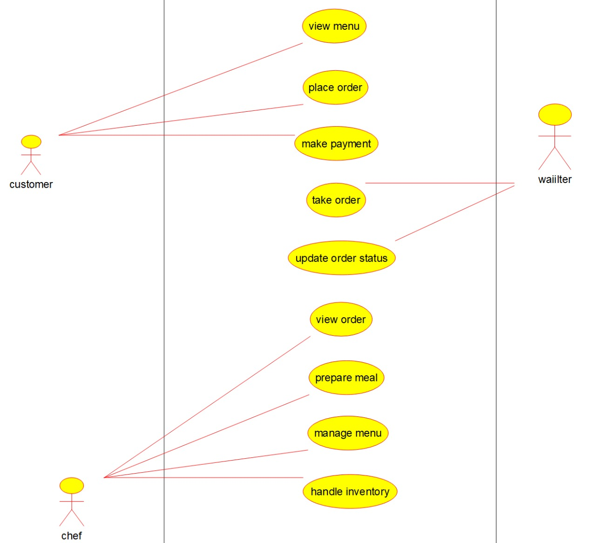

CLASS DIAGRAM:
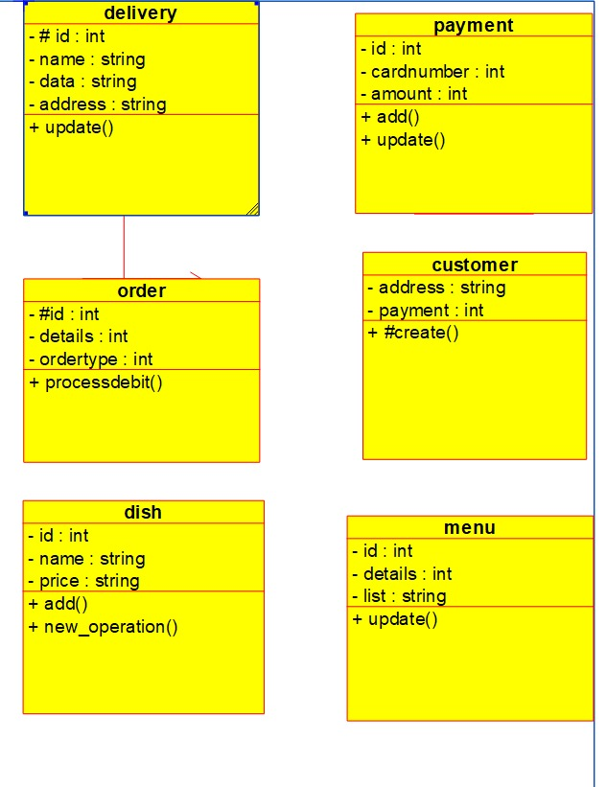

COLLABRATION DIAGRAM :

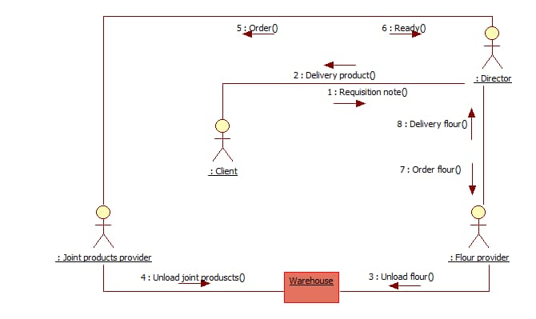

ACTIVITY DIAGRAM:

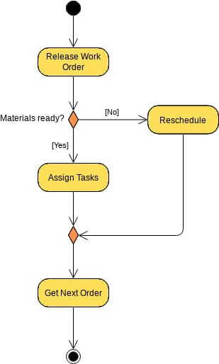

SEQUENCE DIAGRAM:

